How do I find the security interest holder on a manufactured home?

Under Oregon law, a security interest on a manufactured home must be recorded on the structure’s Ownership Document. (ORS 446.571(3)). The Oregon Department of Consumer and Business Services administers the Manufactured Home Ownership Document System, available at mhods.oregon.gov. To locate the secured party, if any, on a manufactured dwelling, take the following steps:

Step 1: Go to mhods.oregon.gov

Step 2: Select “search” in the yellow box on the top of the page. Select “manufactured home.”

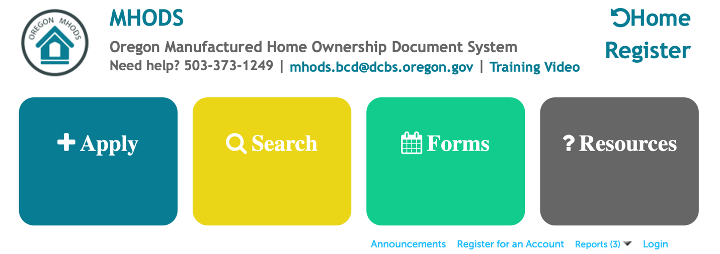

Step 3: When the “search” page opens there will be three options in a drop down menu beneath the arrows.
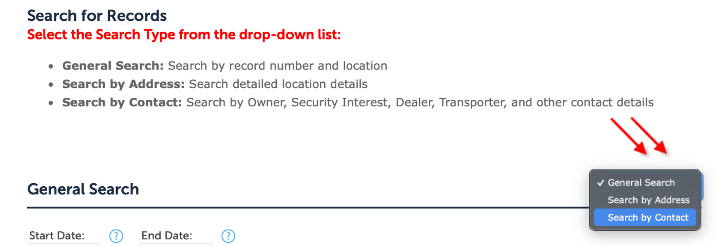

- General Search: choose this option if you are looking for a specific record or a specific unit
- Search by Address: choose this option if you are looking for data on a particular address.
- Search by Contact: choose this option if you are looking up information for a particular owner or security interest holder. You may also search for particular applicants, dealers, legal representatives, or transporters.

Step 4: Once you have chosen a search function and identified the proper record, MHODS will open a page that shows the record number, the status and address, and a section called “Details.” Under Details there is a blue button that says “Print/View Ownership Document.” Pressing that button will open up a new window.

Step 5: After clicking “Print/View Ownership Document” the system will automatically open a new window and populate a box labeled “Alt ID.” Do not make any changes. Click “Submit”

Step 6: A copy of the ownership document will open in the same window. Any current security interest, properly submitted to MHODS, will be displayed.

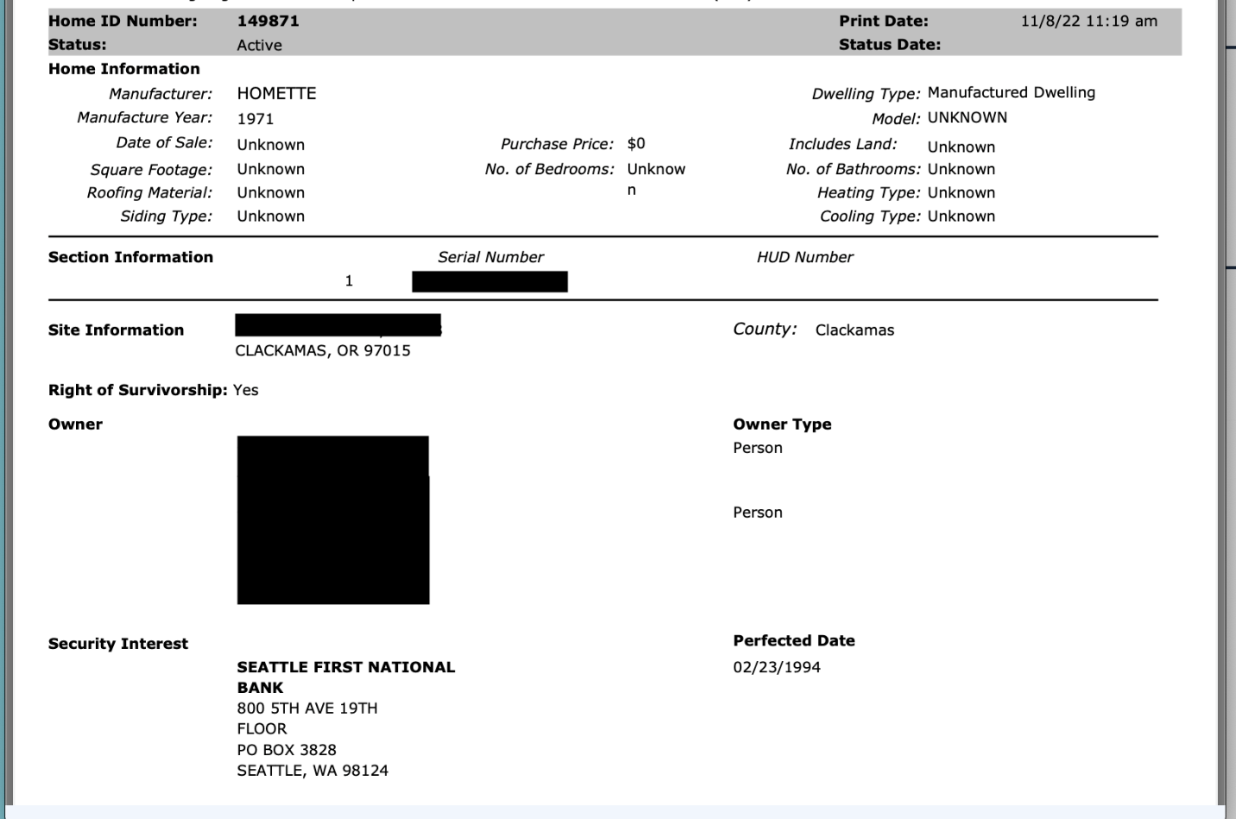

MHODS only lists security interests for mobile homes that are required to have Ownership Documents. Manufactured homes that are considered real property, and therefore have a deed, will have security interests indexed with the recorder’s office in the county in which the property is located.

A manufactured home is considered real property if the owner:
- owns both the structure and the land beneath the structure;
- holds a leasehold of 20 years or more and the lease dictates that the title will be recorded in the county land records; or
- if the mobile home park in which the structure is located is a manufactured dwelling park nonprofit co-op (i.e the park tenants also have an ownership stake in the land beneath the park). (ORS 446.626(1))

Manufactured structures owned by the United States government and manufactured structures held as inventory for a builder or dealer are not required to have Ownership Documents recorded in MHODS. If the owner is a dealer of mobile homes, and the structure constitutes inventory for sale or lease, any security interests will be documented in the records of the Oregon Secretary of State. https://secure.sos.state.or.us/ucc/searchHome.action#

In summary, to find the security interest holder on a manufactured home you must first determine if the manufactured home has an Ownership Document or if it has a deed. If it has an ownership document, then check MHODS for all security interests. If it has a deed, check with the county recorder’s office in the county where the dwelling is located.

If you are looking for any other security interest, check with the Oregon Secretary of State’s UCC search for other relevant financing statements. You may search by debtor or creditor.

Note: MHODS has a helpful training video under the “resources” tab on their main page. The first part of the video demonstrates how to search on the MHODS system, and the latter portion of the video demonstrates how to use MHODS to add or update forms.

